**MongoDB Assignment 1**

**Questions:**

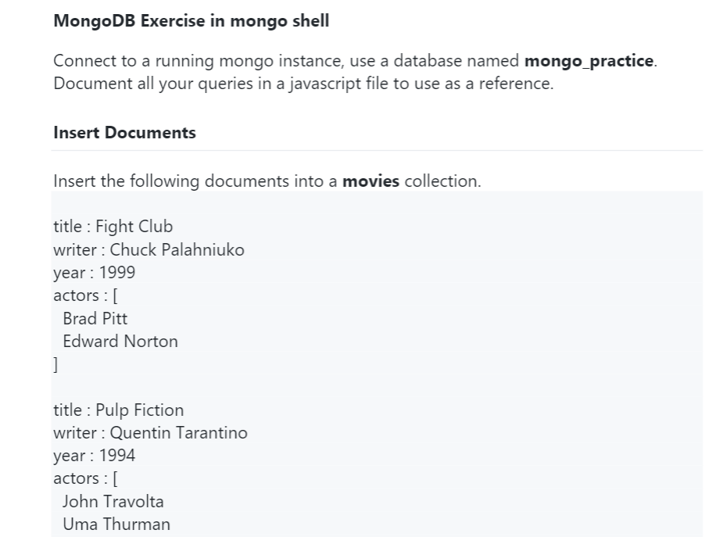

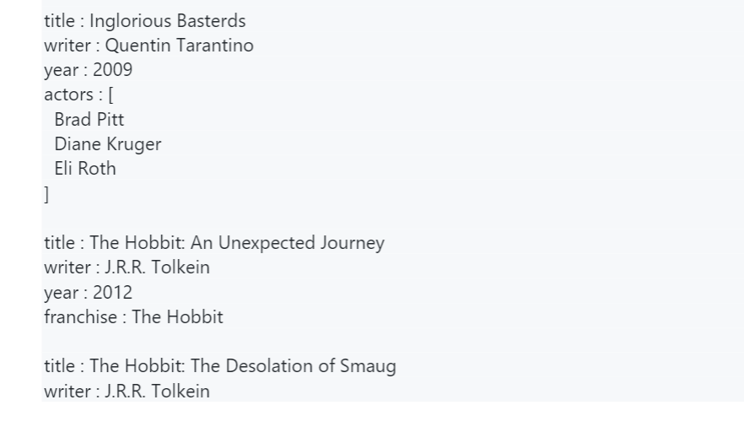

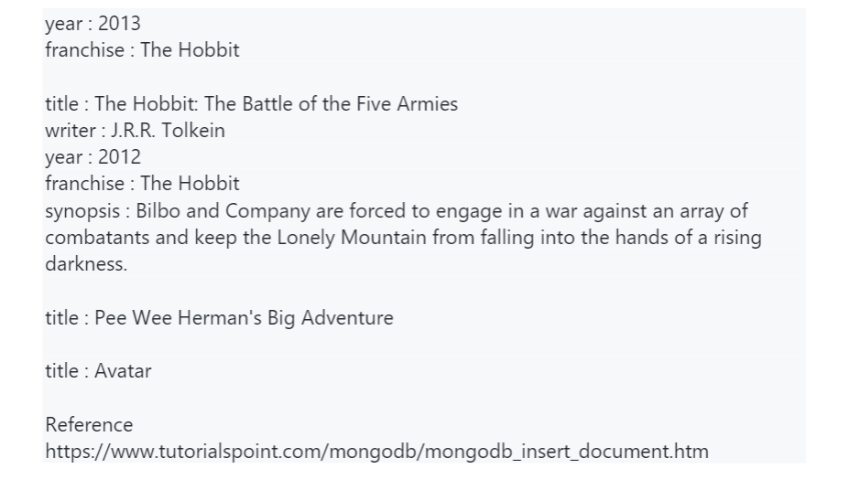

**Comments & Results:**

**> show dbs**

admin 0.000GB

config 0.000GB

local 0.000GB

mongo_practice 0.000GB

**> use mongo_practice**

switched to db mongo_practice

**> show collections;**

movies

**> db.movies.insertOne({'title':'Flight Club','writer':'Chuck Palahniuko','year':1999,'actors':['Brad Pitt','Edward Norton']}**

... )

{

"acknowledged" : true,

"insertedId" : ObjectId("60df1089731986343c07ae92")

}

**> db.movies.insertOne({'title':'Pulp Fiction','writer':'Quenitin Tarantino','year':1994,'actors':['John Travolta','Uma Thurman']})**

{

"acknowledged" : true,

"insertedId" : ObjectId("60df114a731986343c07ae93")

}

**> db.movies.insertOne({'title':'Inglorious Basterds','writer':'Quentin Tarantino','year':2009,'actors':['Brad Pitt','Diane Kruger','Eli Roth']})**

{

"acknowledged" : true,

"insertedId" : ObjectId("60df12ff731986343c07ae94")

}

**> db.movies.insertOne({'title':'The Hobbit: An Unexpected Journey','writer':'J.R.R Tolkein','year':2012,'franchise':'The Hobbit'})**

{

"acknowledged" : true,

"insertedId" : ObjectId("60df13ce731986343c07ae95")

}

**> db.movies.insertOne({'title':'The Hobbit:The Desolation of Smaug','writer':'J.R.R Tolkein','year':2013,'franchise':'The Hobbit'})**

{

"acknowledged" : true,

"insertedId" : ObjectId("60df14b1731986343c07ae96")

}

**> db.movies.insertOne({'title':'The Hobbit:The Battle of the Five Armies','writer':'J.R.R Tolkein','year':2012,'franchise':'The Hobbit','synopsis':'Bilbo and Company are forced to engage in a war against an array of combatants and keep the lonely Mountain from falling into the hands of a raising darkness'})**

{

"acknowledged" : true,

"insertedId" : ObjectId("60df15ad731986343c07ae97")

}

**> db.movies.insertOne({'title':'Pee Wee Herman\'s Big Adventure'})**

{

"acknowledged" : true,

"insertedId" : ObjectId("60df1616731986343c07ae98")

}

**> db.movies.insertOne({'title':'Avatar'})**

{

"acknowledged" : true,

"insertedId" : ObjectId("60df1639731986343c07ae99")

}

**Questions:**

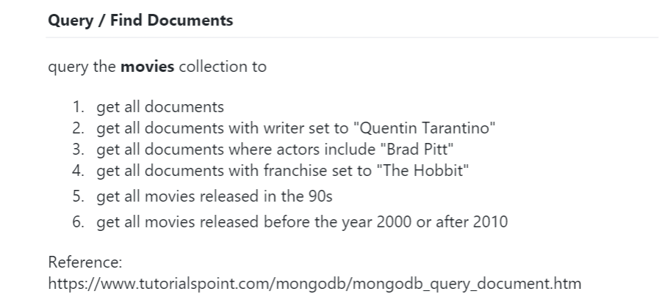

**Comments & Results:**

**> db.movies.find().pretty()**

{

"_id" : ObjectId("60df1089731986343c07ae92"),

"title" : "Flight Club",

"writer" : "Chuck Palahniuko",

"year" : 1999,

"actors" : [

"Brad Pitt",

"Edward Norton"

]

}

{

"_id" : ObjectId("60df114a731986343c07ae93"),

"title" : "Pulp Fiction",

"writer" : "Quenitin Tarantino",

"year" : 1994,

"actors" : [

"John Travolta",

"Uma Thurman"

]

}

{

"_id" : ObjectId("60df12ff731986343c07ae94"),

"title" : "Inglorious Basterds",

"writer" : "Quentin Tarantino",

"year" : 2009,

"actors" : [

"Brad Pitt",

"Diane Kruger",

"Eli Roth"

]

}

{

"_id" : ObjectId("60df13ce731986343c07ae95"),

"title" : "The Hobbit: An Unexpected Journey",

"writer" : "J.R.R Tolkein",

"year" : 2012,

"franchise" : "The Hobbit"

}

{

"_id" : ObjectId("60df14b1731986343c07ae96"),

"title" : "The Hobbit:The Desolation of Smaug",

"writer" : "J.R.R Tolkein",

"year" : 2013,

"franchise" : "The Hobbit"

}

{

"_id" : ObjectId("60df15ad731986343c07ae97"),

"title" : "The Hobbit:The Battle of the Five Armies",

"writer" : "J.R.R Tolkein",

"year" : 2012,

"franchise" : "The Hobbit",

"synopsis" : "Bilbo and Company are forced to engage in a war against an array of combatants and keep the lonely Mountain from falling into the hands of a raising darkness"

}

{

"_id" : ObjectId("60df1616731986343c07ae98"),

"title" : "Pee Wee Herman's Big Adventure"

}

**> db.movies.findOne({writer:'Quentin Tarantino'})**

{

"_id" : ObjectId("60df12ff731986343c07ae94"),

"title" : "Inglorious Basterds",

"writer" : "Quentin Tarantino",

"year" : 2009,

"actors" : [

"Brad Pitt",

"Diane Kruger",

"Eli Roth"

]

}

**> db.movies.findOne({actors:'Brad Pitt'})**

{

"_id" : ObjectId("60df1089731986343c07ae92"),

"title" : "Flight Club",

"writer" : "Chuck Palahniuko",

"year" : 1999,

"actors" : [

"Brad Pitt",

"Edward Norton"

]

}

**> db.movies.findOne({franchise:'The Hobbit'})**

{

"_id" : ObjectId("60df13ce731986343c07ae95"),

"title" : "The Hobbit: An Unexpected Journey",

"writer" : "J.R.R Tolkein",

"year" : 2012,

"franchise" : "The Hobbit"

}

**> db.movies.find({'year':{$lt:2000}}).pretty()**

{

"_id" : ObjectId("60df1089731986343c07ae92"),

"title" : "Flight Club",

"writer" : "Chuck Palahniuko",

"year" : 1999,

"actors" : [

"Brad Pitt",

"Edward Norton"

]

}

{

"_id" : ObjectId("60df114a731986343c07ae93"),

"title" : "Pulp Fiction",

"writer" : "Quenitin Tarantino",

"year" : 1994,

"actors" : [

"John Travolta",

"Uma Thurman"

]

}

**> db.movies.find({$or:[{"year":{$lt:2000}},{"year":{$gt:2010}}]}).pretty()**

{

"_id" : ObjectId("60df1089731986343c07ae92"),

"title" : "Flight Club",

"writer" : "Chuck Palahniuko",

"year" : 1999,

"actors" : [

"Brad Pitt",

"Edward Norton"

]

}

{

"_id" : ObjectId("60df114a731986343c07ae93"),

"title" : "Pulp Fiction",

"writer" : "Quenitin Tarantino",

"year" : 1994,

"actors" : [

"John Travolta",

"Uma Thurman"

]

}

{

"_id" : ObjectId("60df13ce731986343c07ae95"),

"title" : "The Hobbit: An Unexpected Journey",

"writer" : "J.R.R Tolkein",

"year" : 2012,

"franchise" : "The Hobbit"

}

{

"_id" : ObjectId("60df14b1731986343c07ae96"),

"title" : "The Hobbit:The Desolation of Smaug",

"writer" : "J.R.R Tolkein",

"year" : 2013,

"franchise" : "The Hobbit"}

{

"_id" : ObjectId("60df15ad731986343c07ae97"),

"title" : "The Hobbit:The Battle of the Five Armies",

"writer" : "J.R.R Tolkein",

"year" : 2012,

"franchise" : "The Hobbit",

"synopsis" : "Bilbo and Company are forced to engage in a war against an array of combatants and keep the lonely Mountain from falling into the hands of a raising darkness"

}

**Questions:**

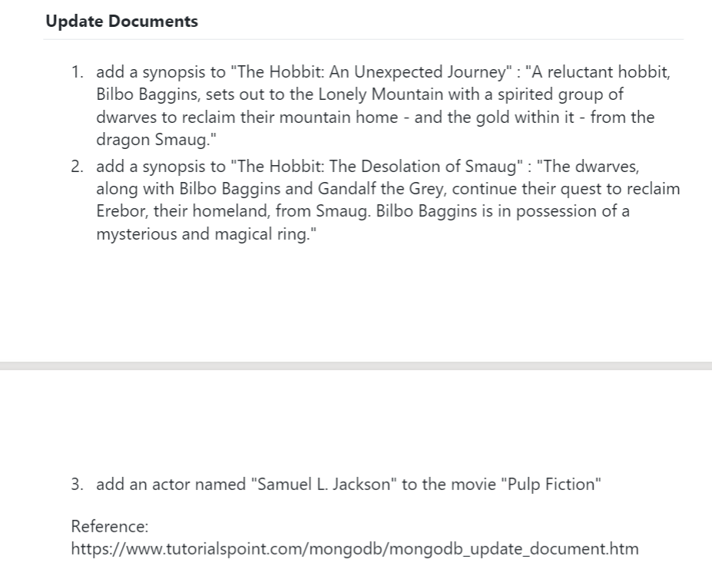

**Comments & Results”**

**> db.movies.findOneAndUpdate({'title':'The Hobbit: An Unexpected Journey'},{$set:{'synopsis':' A reluctant hobbit,Bilbo Baggins,sets out to the Lonely Mountain with a spirited group of dwarves to reclaim their mountain home-and the gold within it- from the dragon Smaug'}})**

{

"_id" : ObjectId("60df13ce731986343c07ae95"),

"title" : "The Hobbit: An Unexpected Journey",

"writer" : "J.R.R Tolkein",

"year" : 2012,

"franchise" : "The Hobbit"

}

**> db.movies.findOneAndUpdate({'title':'The Hobbit:The Desolation of Smaug'},{$set:{'synopsis':'The dwarves,along with Bilbo Baggins and Gandalf the Grey,continue their quest to reclaim Erebor,their homeland,from Smaug.Bilbo Baggains is in possession of a mysterious and magical ring'}})**

{

"_id" : ObjectId("60df14b1731986343c07ae96"),

"title" : "The Hobbit:The Desolation of Smaug",

"writer" : "J.R.R Tolkein",

"year" : 2013,

"franchise" : "The Hobbit"

}

**> db.movies.findOne({actors:'Samuel L.Jackson'})**

{

"_id" : ObjectId("60df114a731986343c07ae93"),

"title" : "Pulp Fiction",

"writer" : "Quenitin Tarantino",

"year" : 1994,

"actors" : [

"John Travolta",

"Uma Thurman",

"Samuel L.Jackson ]}

**Questions:**

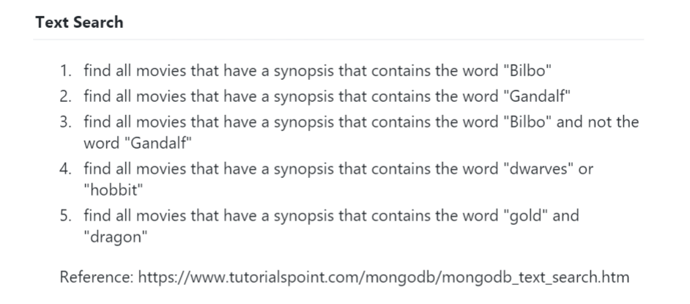

**Comments & Results:**

**db.movies.find().pretty()**

{

"_id" : ObjectId("60df1089731986343c07ae92"),

"title" : "Flight Club",

"writer" : "Chuck Palahniuko",

"year" : 1999,

"actors" : [

"Brad Pitt",

"Edward Norton"

]

}

{

"_id" : ObjectId("60df114a731986343c07ae93"),

"title" : "Pulp Fiction",

"writer" : "Quenitin Tarantino",

"year" : 1994,

"actors" : [

"John Travolta",

"Uma Thurman",

"Samuel L.Jackson"

]

}

{

"_id" : ObjectId("60df12ff731986343c07ae94"),

"title" : "Inglorious Basterds",

"writer" : "Quentin Tarantino",

"year" : 2009,

"actors" : [

"Brad Pitt",

"Diane Kruger",

"Eli Roth"

]

}

{

"_id" : ObjectId("60df13ce731986343c07ae95"),

"title" : "The Hobbit: An Unexpected Journey",

"writer" : "J.R.R Tolkein",

"year" : 2012,

"franchise" : "The Hobbit",

"synopsis" : " A reluctant hobbit,Bilbo Baggins,sets out to the Lonely Mountain with a spirited group of dwarves to reclaim their mountain home-and the gold within it- from the dragon Smaug"

}

{

"_id" : ObjectId("60df14b1731986343c07ae96"),

"title" : "The Hobbit:The Desolation of Smaug",

"writer" : "J.R.R Tolkein",

"year" : 2013,

"franchise" : "The Hobbit",

"synopsis" : "The dwarves,along with Bilbo Baggins and Gandalf the Grey,continue their quest to reclaim Erebor,their homeland,from Smaug.Bilbo Baggains is in possession of a mysterious and magical ring"

}

{

"_id" : ObjectId("60df15ad731986343c07ae97"),

"title" : "The Hobbit:The Battle of the Five Armies",

"writer" : "J.R.R Tolkein",

"year" : 2012,

"franchise" : "The Hobbit",

"synopsis" : "Bilbo and Company are forced to engage in a war against an array of combatants and keep the lonely Mountain from falling into the hands of a raising darkness"

}

{

"_id" : ObjectId("60df1616731986343c07ae98"),

"title" : "Pee Wee Herman's Big Adventure"

}

{ "_id" : ObjectId("60df1639731986343c07ae99"), "title" : "Avatar" }

> db.movies.createIndex({'synopsis':'text'})

{

"createdCollectionAutomatically" : false,

"numIndexesBefore" : 1,

"numIndexesAfter" : 2,

"ok" : 1

}

**> db.movies.find({$text:{$search:'Bilbo'}}).pretty()**

{

"_id" : ObjectId("60df14b1731986343c07ae96"),

"title" : "The Hobbit:The Desolation of Smaug",

"writer" : "J.R.R Tolkein",

"year" : 2013,

"franchise" : "The Hobbit",

"synopsis" : "The dwarves,along with Bilbo Baggins and Gandalf the Grey,continue their quest to reclaim Erebor,their homeland,from Smaug.Bilbo Baggains is in possession of a mysterious and magical ring"

}

{

"_id" : ObjectId("60df15ad731986343c07ae97"),

"title" : "The Hobbit:The Battle of the Five Armies",

"writer" : "J.R.R Tolkein",

"year" : 2012,

"franchise" : "The Hobbit",

"synopsis" : "Bilbo and Company are forced to engage in a war against an array of combatants and keep the lonely Mountain from falling into the hands of a raising darkness"

}

{

"_id" : ObjectId("60df13ce731986343c07ae95"),

"title" : "The Hobbit: An Unexpected Journey",

"writer" : "J.R.R Tolkein",

"year" : 2012,

"franchise" : "The Hobbit",

"synopsis" : " A reluctant hobbit,Bilbo Baggins,sets out to the Lonely Mountain with a spirited group of dwarves to reclaim their mountain home-and the gold within it- from the dragon Smaug"

}

**> db.movies.find({$text:{$search:'Gandalf'}}).pretty()**

{

"_id" : ObjectId("60df14b1731986343c07ae96"),

"title" : "The Hobbit:The Desolation of Smaug",

"writer" : "J.R.R Tolkein",

"year" : 2013,

"franchise" : "The Hobbit",

"synopsis" : "The dwarves,along with Bilbo Baggins and Gandalf the Grey,continue their quest to reclaim Erebor,their homeland,from Smaug.Bilbo Baggains is in possession of a mysterious and magical ring"

}

**> db.movies.find({$text:{$search:"Bilbo -Gandalf"}}).pretty()**

{

"_id" : ObjectId("60df15ad731986343c07ae97"),

"title" : "The Hobbit:The Battle of the Five Armies",

"writer" : "J.R.R Tolkein",

"year" : 2012,

"franchise" : "The Hobbit",

"synopsis" : "Bilbo and Company are forced to engage in a war against an array of combatants and keep the lonely Mountain from falling into the hands of a raising darkness"

}

{

"_id" : ObjectId("60df13ce731986343c07ae95"),

"title" : "The Hobbit: An Unexpected Journey",

"writer" : "J.R.R Tolkein",

"year" : 2012,

"franchise" : "The Hobbit",

"synopsis" : " A reluctant hobbit,Bilbo Baggins,sets out to the Lonely Mountain with a spirited group of dwarves to reclaim their mountain home-and the gold within it- from the dragon Smaug"

}

**> db.movies.find({$text:{$search:"dwarves hobbit"}}).pretty()**

{

"_id" : ObjectId("60df13ce731986343c07ae95"),

"title" : "The Hobbit: An Unexpected Journey",

"writer" : "J.R.R Tolkein",

"year" : 2012,

"franchise" : "The Hobbit",

"synopsis" : " A reluctant hobbit,Bilbo Baggins,sets out to the Lonely Mountain with a spirited group of dwarves to reclaim their mountain home-and the gold within it- from the dragon Smaug"

}

{

"_id" : ObjectId("60df14b1731986343c07ae96"),

"title" : "The Hobbit:The Desolation of Smaug",

"writer" : "J.R.R Tolkein",

"year" : 2013,

"franchise" : "The Hobbit",

"synopsis" : "The dwarves,along with Bilbo Baggins and Gandalf the Grey,continue their quest to reclaim Erebor,their homeland,from Smaug.Bilbo Baggains is in possession of a mysterious and magical ring"

}

**> db.movies.find({$text:{$search:"\"gold\" \"dragon\""}}).pretty()**

{

"_id" : ObjectId("60df13ce731986343c07ae95"),

"title" : "The Hobbit: An Unexpected Journey",

"writer" : "J.R.R Tolkein",

"year" : 2012,

"franchise" : "The Hobbit",

"synopsis" : " A reluctant hobbit,Bilbo Baggins,sets out to the Lonely Mountain with a spirited group of dwarves to reclaim their mountain home-and the gold within it- from the dragon Smaug"

**Questions:**

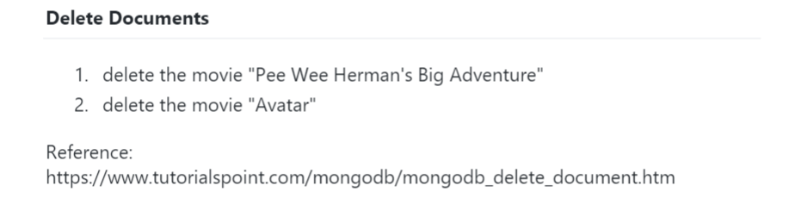

**> db.movies.remove({"title":"Pee Wee Herman's Big Adventure"},{"title":"Avatar"})**

**WriteResult({ "nRemoved" : 1 })**

**> db.movies.remove({"title":"Avatar"})**

**WriteResult({ "nRemoved" : 1 })**

**> db.movies.find().pretty()**

{

"_id" : ObjectId("60df1089731986343c07ae92"),

"title" : "Flight Club",

"writer" : "Chuck Palahniuko",

"year" : 1999,

"actors" : [

"Brad Pitt",

"Edward Norton"

]

}

{

"_id" : ObjectId("60df114a731986343c07ae93"),

"title" : "Pulp Fiction",

"writer" : "Quenitin Tarantino",

"year" : 1994,

"actors" : [

"John Travolta",

"Uma Thurman",

"Samuel L.Jackson"

]

}

{

"_id" : ObjectId("60df12ff731986343c07ae94"),

"title" : "Inglorious Basterds",

"writer" : "Quentin Tarantino",

"year" : 2009,

"actors" : [

"Brad Pitt",

"Diane Kruger",

"Eli Roth"

]

}

{

"_id" : ObjectId("60df13ce731986343c07ae95"),

"title" : "The Hobbit: An Unexpected Journey",

"writer" : "J.R.R Tolkein",

"year" : 2012,

"franchise" : "The Hobbit",

"synopsis" : " A reluctant hobbit,Bilbo Baggins,sets out to the Lonely Mountain with a spirited group of dwarves to reclaim their mountain home-and the gold within it- from the dragon Smaug"

}

{

"_id" : ObjectId("60df14b1731986343c07ae96"),

"title" : "The Hobbit:The Desolation of Smaug",

"writer" : "J.R.R Tolkein",

"year" : 2013,

"franchise" : "The Hobbit",

"synopsis" : "The dwarves,along with Bilbo Baggins and Gandalf the Grey,continue their quest to reclaim Erebor,their homeland,from Smaug.Bilbo Baggains is in possession of a mysterious and magical ring"

}

{

"_id" : ObjectId("60df15ad731986343c07ae97"),

"title" : "The Hobbit:The Battle of the Five Armies",

"writer" : "J.R.R Tolkein",

"year" : 2012,

"franchise" : "The Hobbit",

"synopsis" : "Bilbo and Company are forced to engage in a war against an array of combatants and keep the lonely Mountain from falling into the hands of a raising darkness"

**Questions:**

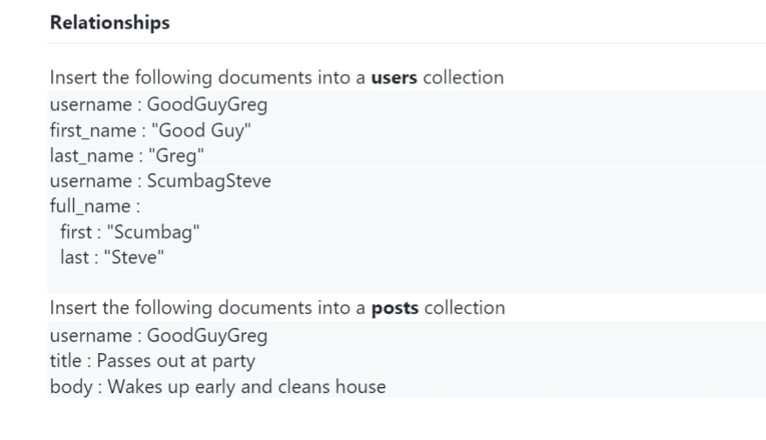

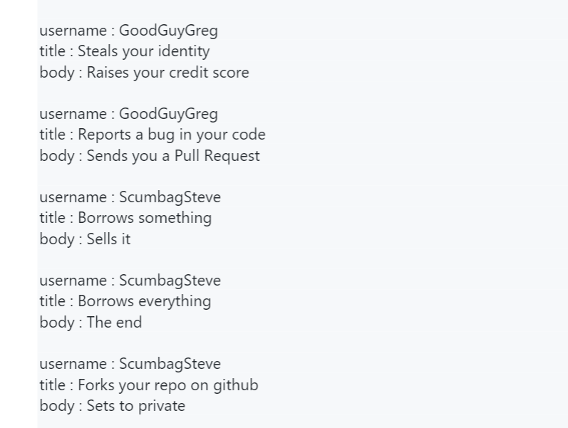

**Comments & Results:**

**> db.posts.insert([**

**... {**

**... _id: 1,**

**... username : "GoodGuyGreg",**

**... title : "Passes out at party",**

**... body : "Wakes up early and cleans house",**

**... },**

**...**

**... {**

**... _id: 2,**

**... username : "GoodGuyGreg",**

**... title : "Steals your identity",**

**... body : "Raises your credit score",**

**... },**

**...**

**... {**

**... _id: 3,**

**... username : "GoodGuyGreg",**

**... title : "Reports a bug in your code",**

**... body : "Sends you a Pull Request",**

**... },**

**...**

**... {**

**... _id: 4,**

**... username : "ScumbagSteve",**

**... title : "Borrows something",**

**... body : "Sells it",**

**... },**

**...**

**... {**

**... _id: 5,**

**... username : "ScumbagSteve",**

**... title : "Borrows everything",**

**... body : "The end",**

**... },**

**...**

**... {**

**... _id: 6,**

**... username : "ScumbagSteve",**

**... title : "Forks your repo on github",**

**... body : "Sets to private",**

**... },**

**... ])**

BulkWriteResult({

"writeErrors" : [ ],

"writeConcernErrors" : [ ],

"nInserted" : 6,

"nUpserted" : 0,

"nMatched" : 0,

"nModified" : 0,

"nRemoved" : 0,

"upserted" : [ ]

})

**> db.posts.find().pretty()**

{

"_id" : 1,

"username" : "GoodGuyGreg",

"title" : "Passes out at party",

"body" : "Wakes up early and cleans house"

}

{

"_id" : 2,

"username" : "GoodGuyGreg",

"title" : "Steals your identity",

"body" : "Raises your credit score"

}

{

"_id" : 3,

"username" : "GoodGuyGreg",

"title" : "Reports a bug in your code",

"body" : "Sends you a Pull Request"

}

{

"_id" : 4,

"username" : "ScumbagSteve",

"title" : "Borrows something",

"body" : "Sells it"

}

{

"_id" : 5,

"username" : "ScumbagSteve",

"title" : "Borrows everything",

"body" : "The end"

}

{

"_id" : 6,

"username" : "ScumbagSteve",

"title" : "Forks your repo on github",

"body" : "Sets to private"}

**Questions:**

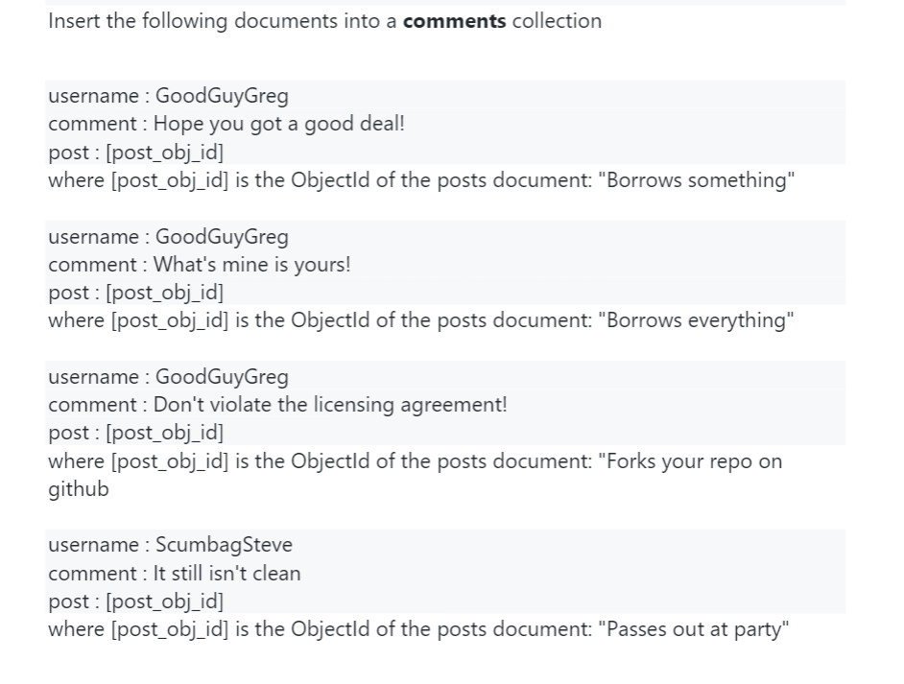

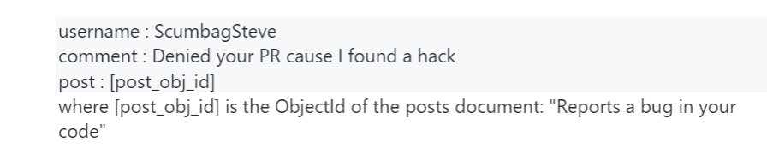

**Comments & Results:**

**> db.comments.insert([**

**... {**

**... username : "GoodGuyGreg",**

**... comment : "Hope you got a good deal!",**

**... post : 4,**

**... },**

**... {**

**... username : "GoodGuyGreg",**

**... comment : "What's mine is yours!",**

**... post : 5,**

**... },**

**... {**

**... username : "GoodGuyGreg",**

**... comment : "Don't violate the licensing agreement!",**

**... post : 6,**

**... },**

**... {**

**... username : "ScumbagSteve",**

**... comment : "It still isn't clean",**

**... post : 1,**

**... },**

**... {**

**... username : "ScumbagSteve",**

**... comment : "Denied your PR cause I found a hack",**

**... post : 3**

**... },**

**... ])**

BulkWriteResult({

"writeErrors" : [ ],

"writeConcernErrors" : [ ],

"nInserted" : 5,

"nUpserted" : 0,

"nMatched" : 0,

"nModified" : 0,

"nRemoved" : 0,

"upserted" : [ ]

})

**Questions:**

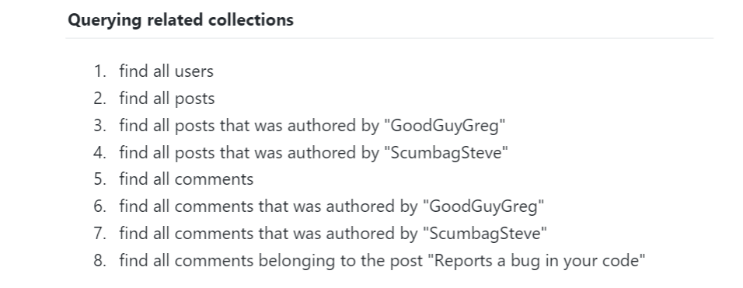

**Comments & Results:**

**> db.comments.find().pretty()**

{

"_id" : ObjectId("60dfface731986343c07aea3"),

"username" : "GoodGuyGreg",

"comment" : "Hope you got a good deal!",

"post" : 4

}

{

"_id" : ObjectId("60dfface731986343c07aea4"),

"username" : "GoodGuyGreg",

"comment" : "What's mine is yours!",

"post" : 5

}

{

"_id" : ObjectId("60dfface731986343c07aea5"),

"username" : "GoodGuyGreg",

"comment" : "Don't violate the licensing agreement!",

"post" : 6

}

{

"_id" : ObjectId("60dfface731986343c07aea6"),

"username" : "ScumbagSteve",

"comment" : "It still isn't clean",

"post" : 1

}

{

"_id" : ObjectId("60dfface731986343c07aea7"),

"username" : "ScumbagSteve",

"comment" : "Denied your PR cause I found a hack",

"post" : 3

}

**> db.comments.createIndex({username:'text'})**

{

"createdCollectionAutomatically" : false,

"numIndexesBefore" : 1,

"numIndexesAfter" : 2,

"ok" : 1

}

**> db.comments.find({$text:{$search:'GoodGuyGreg'}}).pretty()**

{

"_id" : ObjectId("60dfface731986343c07aea5"),

"username" : "GoodGuyGreg",

"comment" : "Don't violate the licensing agreement!",

"post" : 6

}

{

"_id" : ObjectId("60dfface731986343c07aea4"),

"username" : "GoodGuyGreg",

"comment" : "What's mine is yours!",

"post" : 5

}

{

"_id" : ObjectId("60dfface731986343c07aea3"),

"username" : "GoodGuyGreg",

"comment" : "Hope you got a good deal!",

"post" : 4

}

**> db.comments.find({$text:{$search:'ScumbagSteve'}}).pretty()**

{

"_id" : ObjectId("60dfface731986343c07aea7"),

"username" : "ScumbagSteve",

"comment" : "Denied your PR cause I found a hack",

"post" : 3

}

{

"_id" : ObjectId("60dfface731986343c07aea6"),

"username" : "ScumbagSteve",

"comment" : "It still isn't clean",

"post" : 1

}

**> db.comments.find({post: db.posts.findOne({title: "Reports a bug in your** **code"})._id}).pretty()**

{

"_id" : ObjectId("60dfface731986343c07aea7"),

"username" : "ScumbagSteve",

"comment" : "Denied your PR cause I found a hack",

"post" : 3

}